Program No.01:

**CODE:**

<html>

    <head>

        <title>First web page</title>

    </head>

<body>

    <h1>HELLO! My name is </h1>

    <h1><a href="https://www.linkedin.com/in/not-darshil-kumar/">Deepeanshu Malik</a></h1>

    <h2>I am a second year student</h2>

    <p>This is first program of this lab and this program includes hyperlink,head,title,body,paragraph tags.</p>

</body>

</html>

**OUTPUT:**

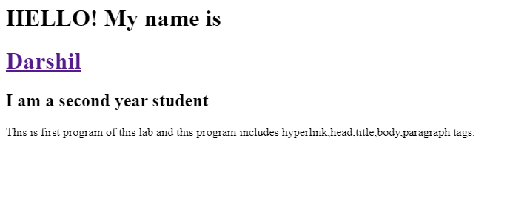

Program No.02:

**CODE:**

<html>

    <head>

        <title>second web page</title>

    </head>

<body>

    <h2>HEllO! My name is <a href="https://www.linkedin.com/in/not-darshil-kumar/">Darshil</a></h2>

    <h2></h2>

    <h2>I am a second year student</h2>

    <p>This is second program of this lab and this program includes bold,italic,underline,subscript,supercript and images tags.</p>

    <p>This is for <b>Bold</b> Tag</p>

    <p>This is for <i>Italic</i> Tag</p>

    <p>This is for <u>Underline</u> Tag</p>

    <p>This is for <sub>Sub Script</sub> Tag</p>

    <p>This is for <sup>Super Script</sup> Tag</p>

    <img src="\images\bg.png" alt="Background" width="1530" height="1200">

</body>

</html>

**OUTPUT:**

